UI/UX

1. What is the difference between UI/UX? Explain in your own words.

Ans- User Interface

UI refers to the visual elements like buttons, toggles, and

Icons, sidebar a user comes across on a website.

* User interface design contains elements that enable users to interact with a product or service.
* UI focuses on the visual elements of the product, website, or app.

User Experience

UX refers to the physical appearance, design, color, and

everything that affects a user's interaction with a digital

product

* User experience contains elements that ensure the user’s smooth and productive interaction with technology.
* UX design’s primary aim is to include elements that ensure smooth user interaction.

1. Who is a front-end developer. Explain roles and responsibilities

In your own words.

Ans - A front-end web developer is responsible for implementing visual elements that users see and interact within a web application.

1. Determining the structure and design of web pages.
2. Ensuring user experience determines design choices.
3. Developing features to enhance the user experience.
4. Building reusable code for future use.
5. Optimizing web pages for maximum speed and scalability.
6. Who is a front-end developer? Explain roles and responsibilities in your own words.

Ans- A back-end web developer is responsible for server-side web application logic and integration of the work front-end web developers do. Back-end developers usually write web services and APIs used by front-end developers.

Back-end developers are responsible for creating, maintaining, testing, and debugging the entire back end of a website. This includes the core application logic, databases, data and application integration, API, and other back end processes.

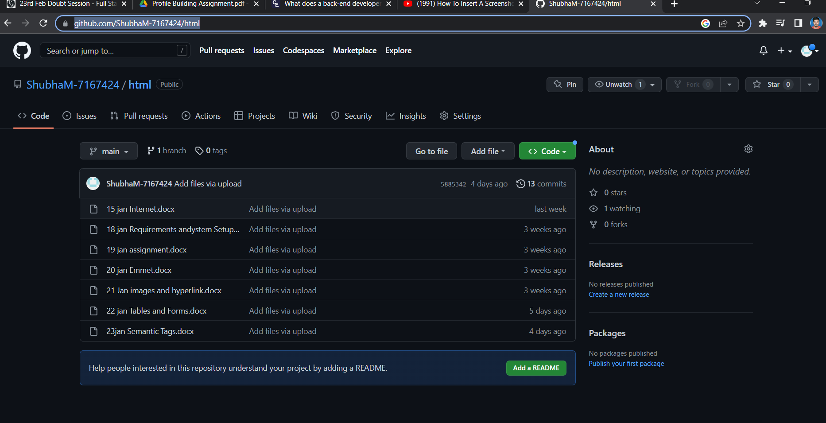

Link - <https://github.com/ShubhaM-7167424/html>

Link - https://www.linkedin.com/in/shubham-singh-b52728153/

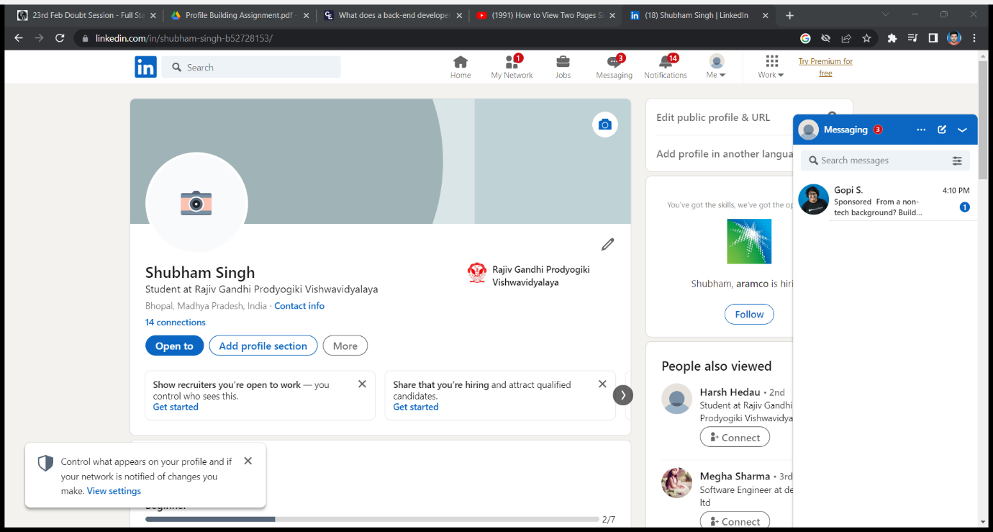

5.Write you first blog on your favorite platform and share the link to the blog.

https://shubham99.hashnode.dev/roadmap-to-web-devlopment-in-2023